# **Name: Abdurrahman Qureshi**

# **Roll No: 242466**

Practical No: 2

1) **Select all rows**

QUERY:

SELECT * FROM emp;

OUTPUT:

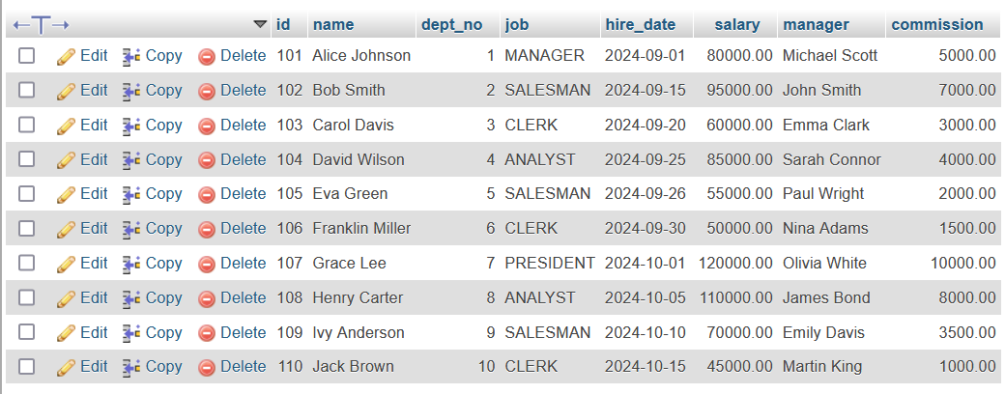

2) **Update commission of Alice to 1000**

QUERY:

UPDATE emp

SET commission = 1000

WHERE name = 'Alice Johnson';

OUTPUT:

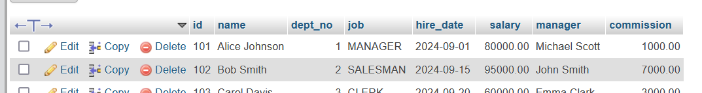

3) **Show details of Carol**

QUERY:

SELECT * FROM emp WHERE name = "Carol Davis";

OUTPUT:

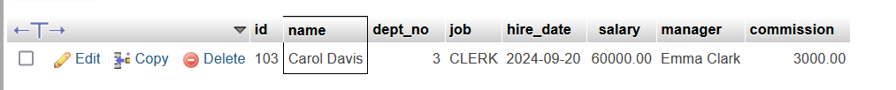

4) **Show records of dept**

QUERY:

SELECT * FROM dept;

OUTPUT:

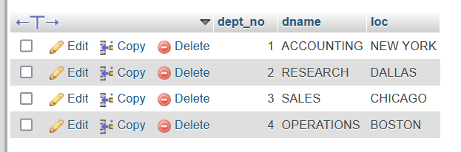

4) **Show all job types**

QUERY:

[SELECT](https://localhost/phpmyadmin/url.php?url=https://dev.mysql.com/doc/refman/8.0/en/select.html) DISTINCT job from emp;

OUTPUT:

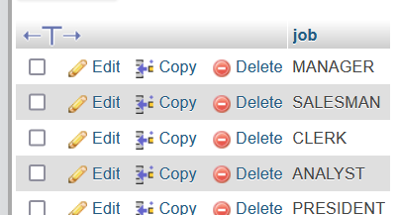

5) **Show all emp of dept 3**

QUERY:

[SELECT](https://localhost/phpmyadmin/url.php?url=https://dev.mysql.com/doc/refman/8.0/en/select.html) * FROM `emp` WHERE dept_no = 3;

OUTPUT:

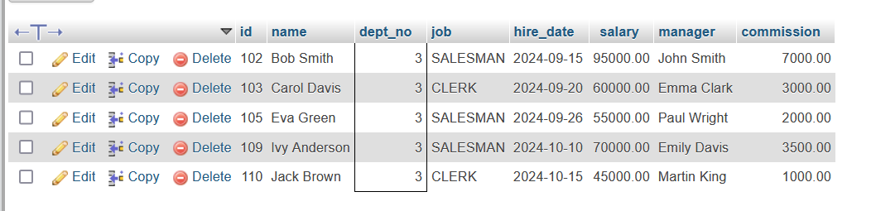

5) **Show all salesman**

QUERY:

SELECT name,id FROM `emp` WHERE job = "SALESMAN";

OUTPUT:

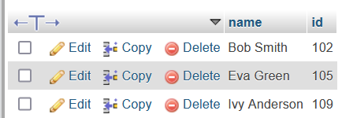

6) **Show name and job whose salary is greater 85k**

QUERY:

[SELECT](https://localhost/phpmyadmin/url.php?url=https://dev.mysql.com/doc/refman/8.0/en/select.html) job,name FROM `emp` WHERE salary > 85000;

OUTPUT:

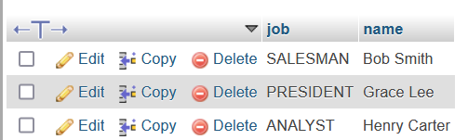

7) **Show monthly and annual salary of all**

QUERY:

[SELECT](https://localhost/phpmyadmin/url.php?url=https://dev.mysql.com/doc/refman/8.0/en/select.html) salary, salary *2 from emp;

OUTPUT:

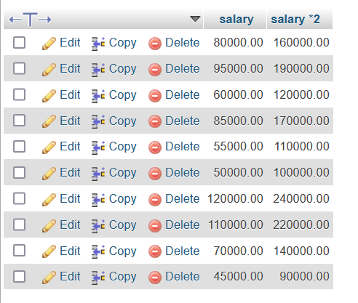

8) **Show dept using aliases**

QUERY:

SELECT dept_no as DEPARTMENT_NUMBER , dname as DEPARTMENT_NAME from dept;

OUTPUT:

